Brainstorm

TIP
You can select a sticky note and hit the pencil [switch to sketch] icon to start drawing!

Before you collaborate

A little bit of preparation goes a long way with this session. Here’s what you need to do to get going.

10 minutes
1

Define your problem statement

What problem are you trying to solve? Frame your problem as a How Might We statement. This will be the focus of your brainstorm.

5 minutes
2

Brainstorm

Write down any ideas that come to mind that address your problem statement.

10 minutes
3

Group ideas

Take turns sharing your ideas while clustering similar or related notes as you go. Once all sticky notes have been grouped, give each cluster a sentence-like label. If a cluster is bigger than six sticky notes, try and see if you and break it up into smaller sub-groups.

20 minutes
4

Prioritize

Your team should all be on the same page about what's important moving forward. Place your ideas on this grid to determine which ideas are important and which are feasible.

20 minutes

After you collaborate
You can export the mural as an image or pdf to share with members of your company who might find it helpful.

& idea prioritization

PROBLEM

How might we [your problem statement]?

- Team gathering

TIP
Add customizable tags to sticky notes to make it easier to find, browse, organize, and categorize important ideas as themes within your mural.

It should be effordable

User friendly

Raspberrypi

Arduino

KRSHNAPRIYA

BHAVANA DEEPIKA

HEMAPRIYA
Hardware device
Ui interface
cost
Quick add-ons

Define who should participate in the session and send an
invite. Share relevant information or pre-work ahead.

Farmers should

Incase of

Bettery must be used to

Interface

more pictorial representation

Final

arduino

Pictorial

As majority of farmers are
If there is nay malfunction full system should be shut down.

The waste
A Share the mural
Share a view link to the mural with stakeholders to keep

be provided
emergency, the
sustain in the

should be
Eco-
should be
outcome
device can representation
illiterates, Icon Python can can be stored

Use this template in your own
with the user friendly interface.
system should be play an effective role.

power cut situation.

It should be affordable.

Pictorial representation
easy to understand
Friendly

used than words
should be user friendly

be used
is the best than the fonts

representation is the best way

be used
and reused as bio wastes
them in the loop about the outcomes of the session.

The waste

Pictorial representation
Humidity and
Solar panels we should build
motors can be
The intruders
The whole
Every details
Cloud storage
Let's"go with We shouldn't

brainstorming sessions so your team

Raspberrypi

Set the goal

Cost must
should be
tempurature measurement
can be used the device which connected with will reduce the
like birds and system should should be stored
in the database

should be
solar pannels to overcome
make the
Export the mural

can unleash their imagination and start shaping concepts even if you're not sitting in the same room.
Think about the problem you'll be focusing on solving in
the brainstorming session.

- Learn how to use the facilitation tools
Use the Facilitation Superpowers to run a happy and
Every readings should be stored in the cloud

User friendly

affordable.
discarded

perfectly.

Since it is used by farmers,it should have more icon representation than english fonts.
should be
periodically sent to the farmers.
for back up
power

The complete informations should be stored in the cloud for future access
work and stress of the farmers
can be
controlled from anywhere
this device which
rats should be
drive away

Battery back up is must
be water
resistant
for future reference
maintained
effectively
Incase of any malfunction the whole system should be shut down immediately
the powre cut situations
operations
complex
Emergency alert Accessibility

If there is any malfuction full system should be shut down
Incase of high value of humidity and temperature farmers will receive alert messages

It should be only accessed by the owner of the farm

Unknown users shouldn'tb be allowed to access the informations
B
Export a copy of the mural as a PNG or PDF to attach to emails, include in slides, or save in your drive.

10 minutes to prepare
1 hour to collaborate
2-8 people recommended
productive session.

Open article

Key rules of brainstorming
To run an smooth and productive session

Keep moving forward

Strategy blueprint
Define the components of a new idea or strategy.

Open the template

Customer experience journey map
Understand customer needs, motivations, and

Stay in topic. Defer judgment.
Encourage wild ideas. Listen to others.

Importance
If each of these
obstacles for an experience.

Open the template

It should be only accessed by the owner of the farm
Incase of value of humidity and temperature farmers will receive alert message.
Unknow user shouldn't be allowed to access the information

Arduino

Go for volume. If possible, be visual.
tasks could get
done without any difficulty or cost, which would have the most positive impact?

Strengths, weaknesses, opportunities & threats
Identify strengths, weaknesses, opportunities, and threats (SWOT) to develop a plan.

Java script

Open the template

TIP
Participants can use their cursors to point at where sticky notes should go on the grid. The facilitator can confirm the spot by using the laser pointer holding the H key on the keyboard.

Share template feedback

Python

Share template feedback

Feasibility
Regardless of their importance, which tasks are more feasible than others? (Cost, time, effort, complexity, etc.)

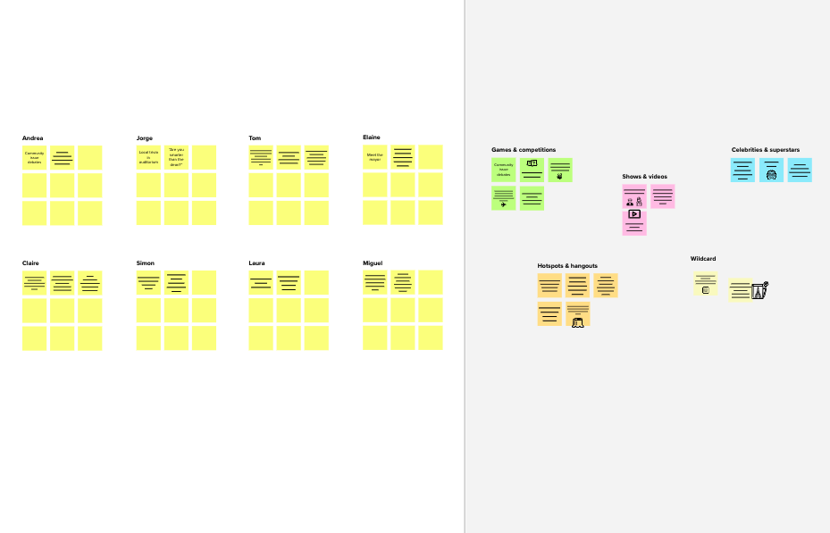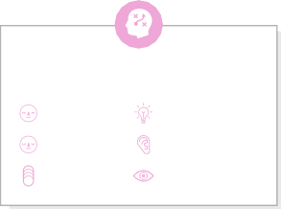
Template

Need some inspiration?
See a finished version of this template to kickstart your work.

Open example

